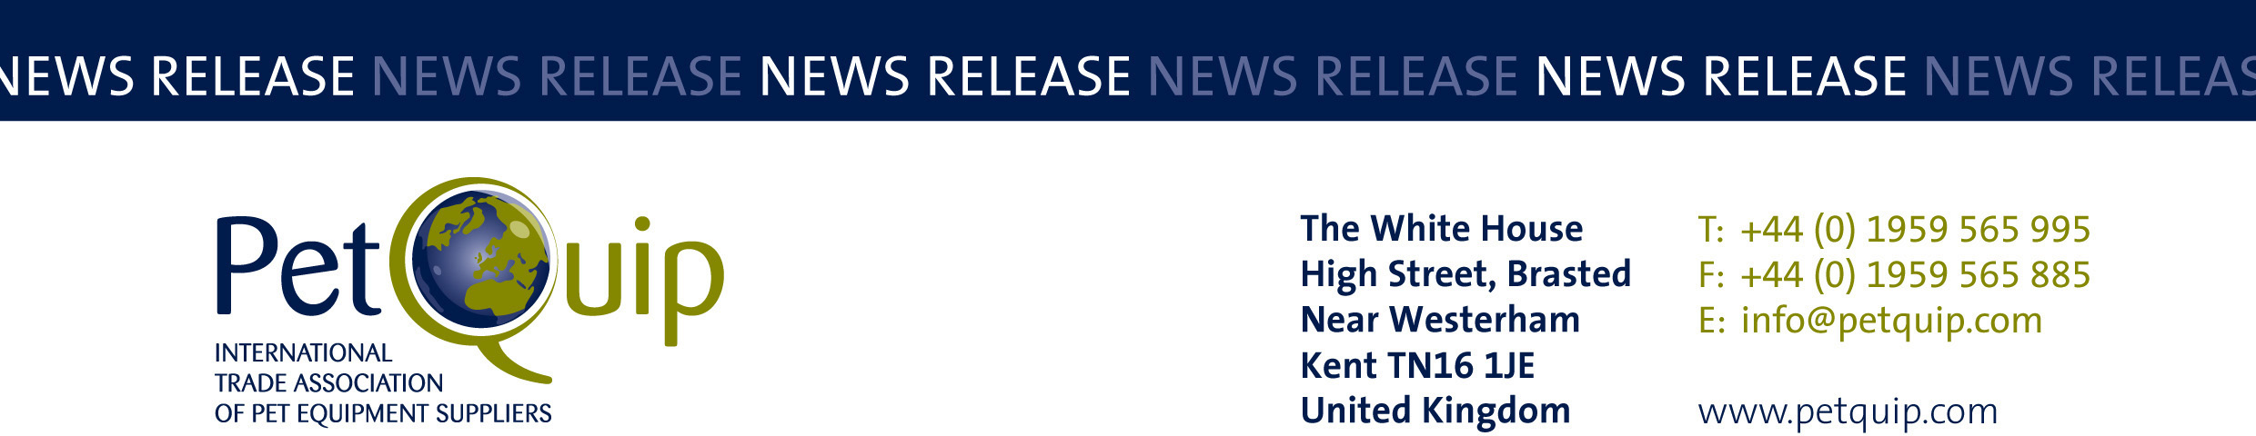

A division of The Federation of Garden and Leisure Manufacturers Limited
Registered in England and Wales No. 706025. Registered Office as above. VAT Registration No. 230906018

FOR IMMEDIATE RELEASE 15th April 2020

PATS Telford and PetQuip Awards set to reunite pet industry
in new ‘Oscar-style’ setting

PATS Telford and the PetQuip Awards are set to play an important role in bringing the whole pet industry back together after the current coronavirus crisis.

The UK’s National Pet Industry Exhibition takes place on 27-28 September 2020, and the country’s leading brands, as well as a long list of new companies, will gather at Telford International Centre for the first time since PATS Sandown in February.

And PATS is pleased to announce that the PetQuip Awards will also be presented at a new-look event on the first evening of the exhibition.

The PetQuip Awards, now in their eighth year, have consistently delivered a professional, enjoyable and successful networking evening event for the whole industry.

“It is important to bring the trade together for what is going to be the first time for months, certainly since PATS Sandown,” said organiser Gordon Thomas, of Impact Exhibitions and Events.

“We have been working even harder this year to make sure PATS Telford and the PetQuip Awards are the BEST in the business.

“We are extremely pleased that the Awards will again be taking place after the first day of PATS Telford and proud to back such a prestigious event.”

The PATS Telford New Product Awards, sponsored by pbwnews, will also be presented during the PetQuip Awards event and party.

The PetQuip Awards event is the pre-eminent pet industry awards event and will take place in a new ‘Oscar-style’ setting with even more opportunities for the whole trade to network, relax and enjoy each other’s company.

The evening will start with a drinks reception, followed by presentations of the PATS New Products Awards and then the Oscar-style announcement of the winners of the PetQuip Awards.

Guests will then be able to enjoy an international-themed buffet and informal evening entertainment.

“We have had some great entries already, particularly from UK retailers, who are making such a big difference during the current crisis,” said Pat Flynn, PetQuip Trade Association Manager.

“We are looking forward to 27 September when we can celebrate together again. The new-look PetQuip Awards will provide suppliers and retailers with the chance to network in a relaxed and informal setting. We hope to create a real party atmosphere and provide a great value evening for a ticket price of only £79 plus VAT (£69 plus VAT for PetQuip members).”

Henry & Co Dog Boutique was shortlisted in the 2019 PetQuip Retailer of the Year category, and owner Arlene Miller said she would be going the extra mile to achieve gold this year.

“I was so lucky to attend last year, winning silver. It was fantastic to be recognised in this industry-wide event. Thanks to PetQuip I met a lot of amazing people who gave me so much advice and support. I hope to attend again and maybe I’ll be lucky enough to win gold this time,” added Arlene.

Entry into the awards is free and is now open. The categories are:
• Marketing Project of the Year
• Exporter of the Year
• Product of the Year (three categories): Accessories/Technical; Food/Treats;
Healthcare/Animal Grooming
• Supplier of the Year
• International Pet Retailer/Distributor of the Year
• UK Pet Retailer of the Year
• Lifetime Achievement

Entries will be put through an initial screening test and the finalists will be announced before an independent judging panel sits down to choose the winners at the end of August. To enter visit www.petquip.com/awards to download an entry form or email info@petquip.com

A full and up-to-date list of exhibitors at PATS Telford is available on the website www.patshow.co.uk together with information on how to reach the venue and regularly updated show news.

Contact PetQuip if you require further advice and assistance:
Tel: +44 (0) 44 1959 565995
Email: info@petquip.com
Website: www.petquip.com

For further press information contact:
Neil Pope
PetQuip PR Consultant
Tel: 07595 442601
Email: press@petquip.com

This announcement has been issued by Neil Pope PR Consultant on behalf of The Federation of Garden & Leisure Manufacturers Limited from information provided by the Federation or from organisations associated with the Federation’s initiatives. Reasonable steps have been taken to ensure that the information it contains provided is accurate. However, Neil Pope PR Consultant assumes no responsibility for information contained within the document and disclaims all liability in respect of such information. Neil Pope PR Consultant shall not be held liable for any losses suffered as a result of issuing this information to the press or its use within the media.

