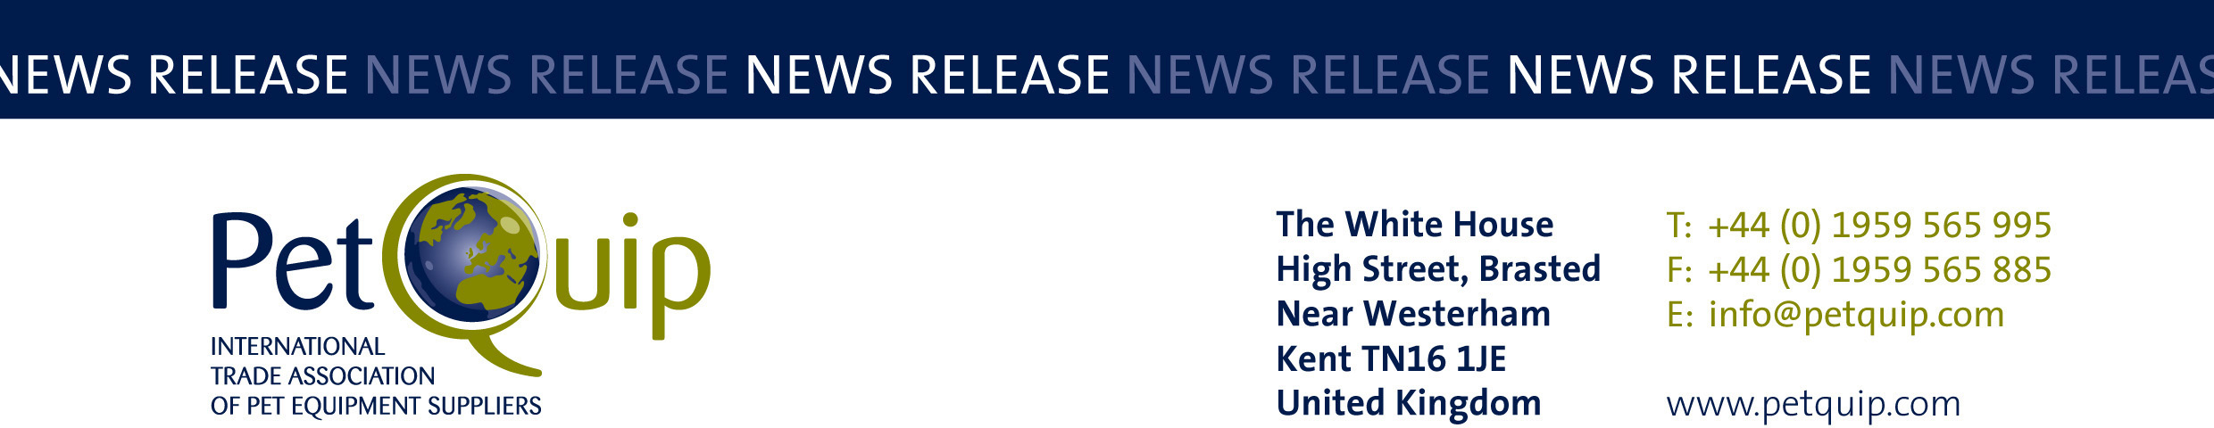

A division of The Federation of Garden and Leisure Manufacturers Limited
Registered in England and Wales No. 706025. Registered Office as above. VAT Registration No. 230906018

FOR IMMEDIATE RELEASE 7th May 2020

PetQuip Awards provide much needed boost for pet industry

Winning a prestigious industry honour like a PetQuip Award could be just the tonic needed by companies following the current coronavirus pandemic.

As well as being recognised and rewarded for outstanding performance by the pet trade, a PetQuip Award would provide a welcome morale boost for pet product suppliers and retailers after such a traumatic period of time.

Entries for the 2020 awards are open, with judging taking place in August and the winners being announced at a special ‘Oscar-style’ event during PATS Telford on 27th September.

The PetQuip Awards, now in their eighth year, have consistently delivered professional recognition of the pet industry’s successes, celebrated at an enjoyable and lively networking event for the whole industry.

One of the most successful winners in PetQuip Awards history is innovative company HOWND, which has received an impressive four gold awards.

HOWND first did the ‘double’ in 2017 when it was awarded Marketing Project of the Year for its ‘Bring Your Dog to Work Day’ campaign, and Pet Product of the Year (Accessories) for its All Seasons Natural Skin, Nose and Paw Balm.

A year later HOWND repeated its success by retaining the Marketing Project of the Year crown for the same campaign, and picking up a second gold for Pet Product of the Year (Food/Treats) with Hemp Wellness Treats.

Jo Amit, co-founder of HOWND, explains how winning multiple PetQuip Awards has boosted business for the company.

She said: “It’s a great boost to morale and to see our peers in the industry so genuinely happy for us when our name was announced at the awards dinner. Who isn’t grateful for a big pat on the back now and again?

“Even the smallest of suppliers should enter. I recommend submitting your entry with the same passion you infused in your product or campaign. Honesty and integrity are key. Just tell your story.”

Jo confirms that winning PetQuip Awards has helped to promote the HOWND brand, adding: “We use them in all of our marketing materials, brand videos, even our price lists and email footers. It’s something we are very proud of.”

And she recommends booking places for your company’s team at the PetQuip Awards gala presentation evening: “It’s a fun and relaxed night out after a long day at PATS Telford. You don’t often get the chance to unwind with your colleagues in the industry and the atmosphere is lovely.”

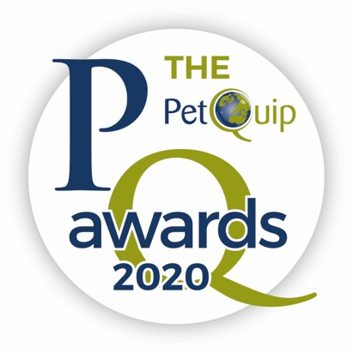

The categories for this year’s PetQuip Awards are:
• Marketing Project of the Year
• Exporter of the Year
• Product of the Year (three categories):
Accessories/Technical
Food/Treats
Healthcare/Animal Grooming
• Supplier of the Year
• International Pet Retailer/Distributor of the Year
• UK Pet Retailer of the Year
• Lifetime Achievement

The deadline for entries is 30th June 2020. Entries will be put through an initial screening test and the finalists will be announced to the trade before an independent judging panel sits down to choose the winners at the end of August.

To enter your company in these prestigious awards, visit www.petquip.com/awards to download an entry form or email info@petquip.com

Contact PetQuip if you require further advice and assistance:
Email: info@petquip.com
Website: www.petquip.com

For further press information contact:
Neil Pope
PetQuip PR Consultant
Tel: 07595 442601
Email: press@petquip.com

This announcement has been issued by Neil Pope PR Consultant on behalf of The Federation of Garden & Leisure Manufacturers Limited from information provided by the Federation or from organisations associated with the Federation’s initiatives. Reasonable steps have been taken to ensure that the information it contains provided is accurate. However, Neil Pope PR Consultant assumes no responsibility for information contained within the document and disclaims all liability in respect of such information. Neil Pope PR Consultant shall not be held liable for any losses suffered as a result of issuing this information to the press or its use within the media.

